R = 8 ohms

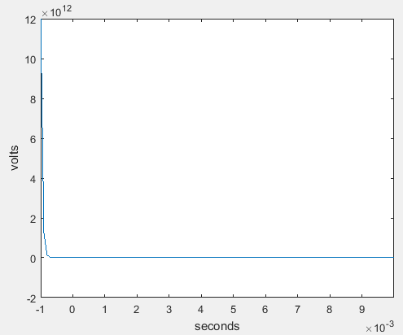

R = 33 ohms

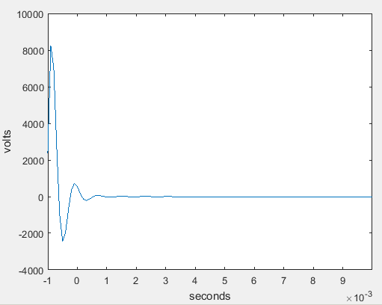

R = 100 ohms

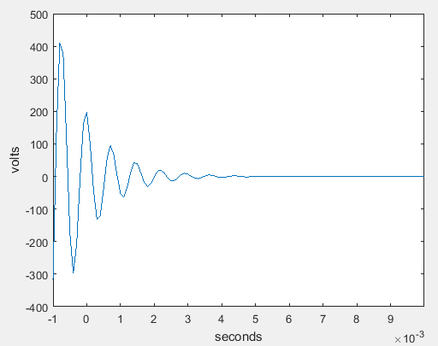

r = 8;

rs = 50;

rg = r*10;

l = 2.78e-3;

c = 4.83e-6;

t = -1:1e-4:10e-3;

p1 = (-1/(2*r*c))+ sqrt((1/(4*r^2*c^2)) - 1/(c*l));

p2 = (-1/(2*r*c))- sqrt((1/(4*r^2*c^2)) - 1/(c*l));

h_t = (1/(c*(p1-p2)*(rs+rg)))*(p1*exp(p1*t)-p2*exp(p2*t));

figure(1);

plot(t, h_t);

xlim([-1e-3 1e-2]);

xlabel('seconds');

ylabel('volts');

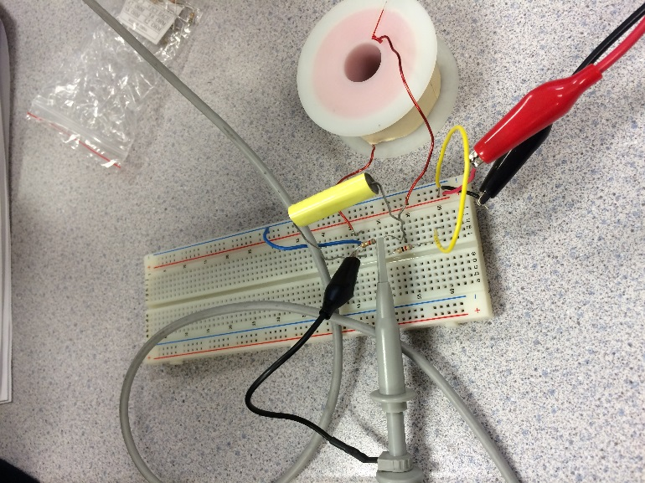

R = 8.2 ohms

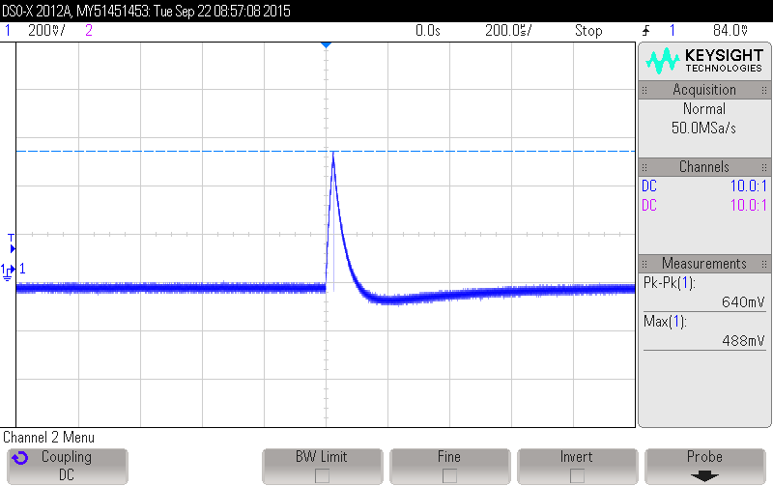

R = 33 ohms

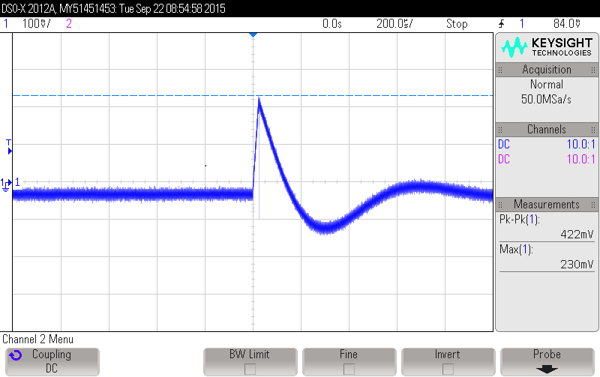

R = 100 ohms

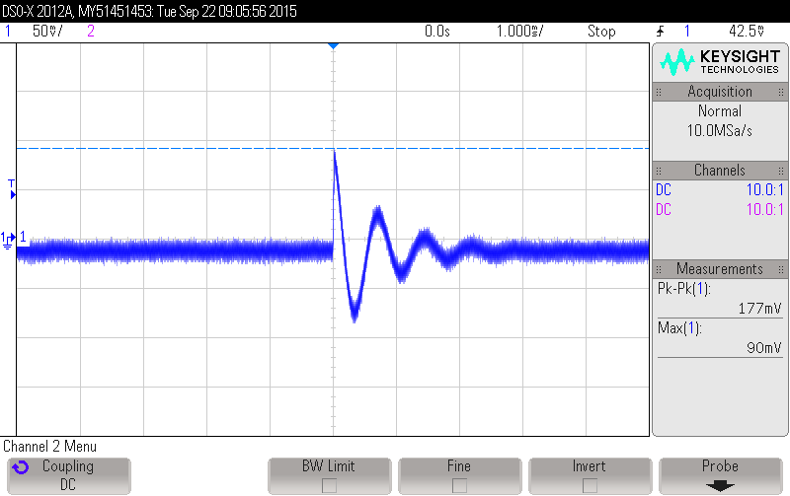

Calculated scale factor: R = 8, scale factor: 1600/.5 = 3200

R = 30, scale factor: 550/.23 = 2391

R = 100, scale factor: 200 / .09 = 2222

R=8

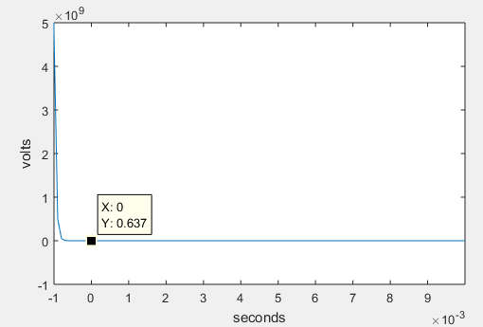

R=33

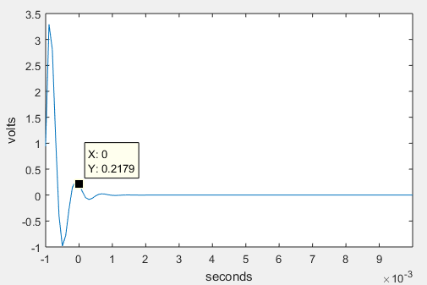

R=100

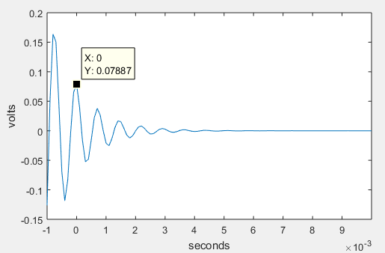

r = 100;

rs = 50;

rg = r*10;

l = 2.78e-3;

c = 4.83e-6;

t = -1:1e-4:10e-3;

scaleFactor = 2500;

p1 = (-1/(2*r*c))+ sqrt((1/(4*r^2*c^2)) - 1/(c*l));

p2 = (-1/(2*r*c))- sqrt((1/(4*r^2*c^2)) - 1/(c*l));

h_t = ((1/(c*(p1-p2)*(rs+rg)))*(p1*exp(p1*t)-p2*exp(p2*t))) / scaleFactor;

figure(1);

plot(t, h_t);

xlim([-1e-3 1e-2]);

xlabel('seconds');

ylabel('volts');

Output to a rect. function with R = 33 ohms

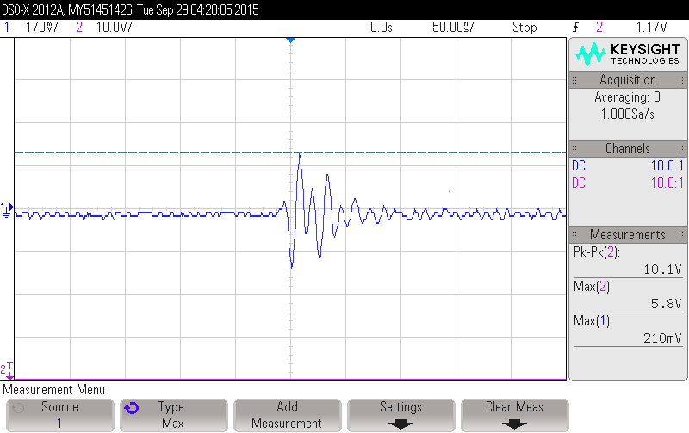

Output to a rect. function with R = 100 ohms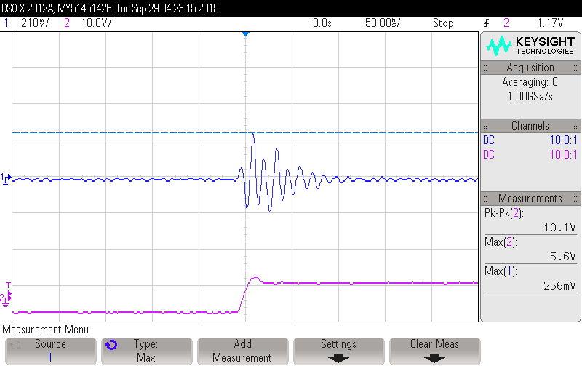

Output to a rect. function with R = 8 ohms

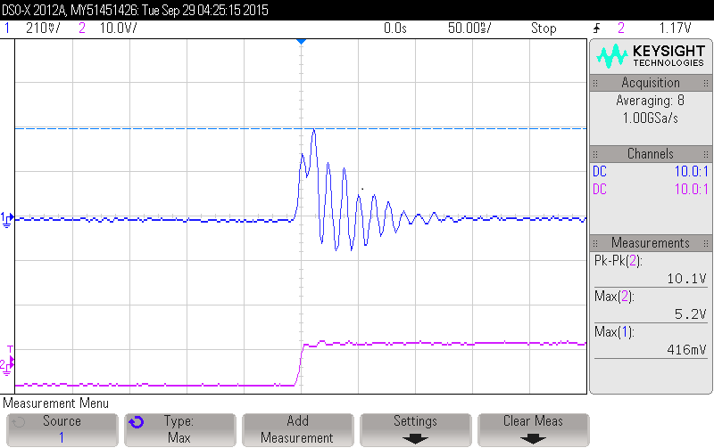

Convolution of h_t and rect_t with R = 100 ohms

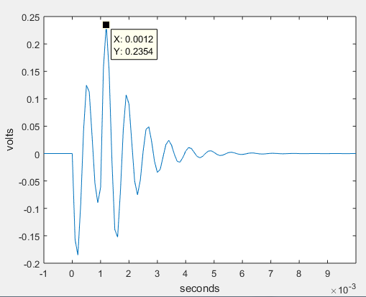

Convolution of h_t and rect_t with R = 33 ohms

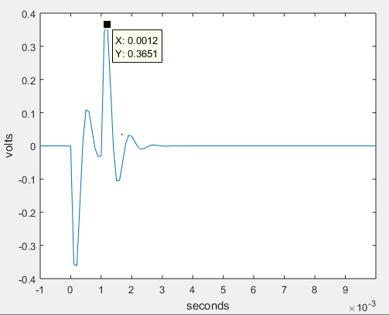

Convolution of h_t and rect_t with R = 8 ohms

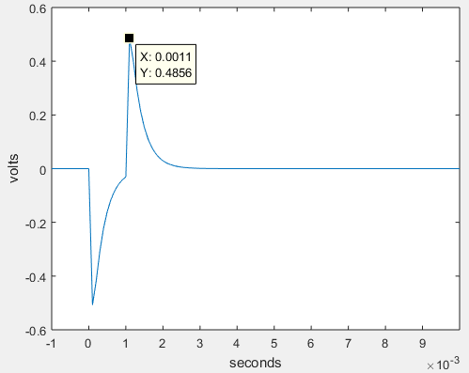

Convolution Code:

r = 8;

rs = 50;

rg = r*10;

l = 2.78e-3;

c = 4.83e-6;

t = -1:1e-4:10e-3;

scaleFactor = 2500;

p1 = (-1/(2*r*c))+ sqrt((1/(4*r^2*c^2)) - 1/(c*l));

p2 = (-1/(2*r*c))- sqrt((1/(4*r^2*c^2)) - 1/(c*l));

h_t = ((1/(c*(p1-p2)*(rs+rg)))*(p1*exp(p1*t)-p2*exp(p2*t))) / scaleFactor;

t_0 = 1e-3;

t1 = t - t_0;

constant = 1/(c*(p1-p2)*(rs+rg));

funct1 = constant*(-exp(p1*(t)) + exp(p2*(t))).*(t<t_0);

funct2 = constant*(-exp(p1*(t))+ exp(p2*(t)) + exp(p1*(t1))-exp(p2*(t1))).*(t>=t_0);

Convolved = (funct1 + funct2).*(t>0).*10;

figure(1);

plot(t, Convolved);

xlim([-1e-3 1e-2]);

xlabel('seconds');

ylabel('volts');

Matlab Code with conv funct.

r = 33;

rs = 50;

rg = r*10;

l = 2.78e-3;

c = 4.83e-6;

t = -.001:1e-5:10e-3;

scaleFactor = 2500;

p2 = (-1/(2*r*c))+ sqrt((1/(4*r^2*c^2)) - 1/(c*l));

p1 = (-1/(2*r*c))- sqrt((1/(4*r^2*c^2)) - 1/(c*l));

h_t = ((1/(c*(p1-p2)*(rs+rg)))*(p1*exp(p1.*t)-p2*exp(p2.*t))) / scaleFactor.* (t >= 0);

t_0 = 1e-3;

rect_t = double(t>=0 & t <= t_0);

x = conv(rect_t, h_out);

figure(1);

plot(x);

xlabel('seconds');

ylabel('volts');

R = 8, 33, 100 All three graphs produced this output.9

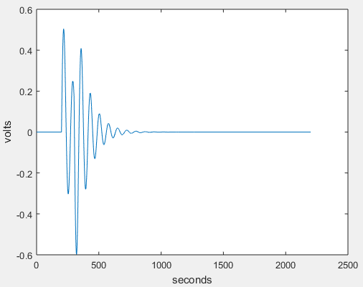

5. Other possible sources of error include: differences in actual values of the inductor and capacitor. We did not measure what the exact value of them were. We just used the printed value and did not take into account the tolerance. Other issues are noise when taking the values from o-scope,

TASK TWO SIGN OFF x_____________________________________

Task 3: 3. How closely does your plot match the real observed result?